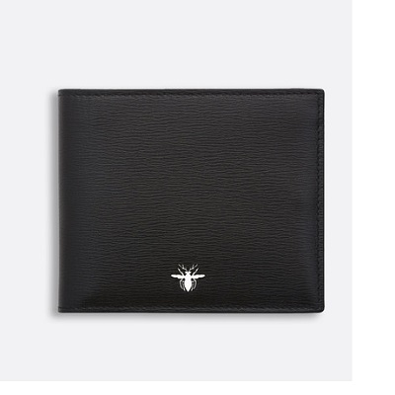

Black textured calfskin wallet with bee signature

PRODUCT DETAILS

**Wallet**

**Black textured calfskin**

**Palladium-finish bee on the outside, emblematic of Dior**

**"Dior" logo heat embossed on the inside**

**8 card slots**

**2 compartments**

**2 document compartments**

**11,5 x 9,5 cm**